**Title:** Warmer spring temperatures in temperate deciduous forests cause earlier tree growth but have little effect on annual woody productivity

**Authors (not yet complete, just alphabetical for now–final order TBD):**

Cameron Dow1

Albert Y. Kim1,2

Loïc D’Orangeville3,4

Erika B. Gonzalez-Akre1

Ryan Helcoski1

Valentine Herrmann1

Ian McGregor1,5

William McShea1

Sean McMahon6,7

David A. Orwig3

Neil Pederson3

Kristina J. Anderson-Teixeira1,7*

**Author Affiliations:**

1. Conservation Ecology Center; Smithsonian Conservation Biology Institute; Front Royal, VA 22630, USA
2. Statistical & Data Sciences; Smith College; Northampton, MA 01063, USA
3. Harvard Forest, Petersham, MA 01366, USA
4. Faculty of Forestry and Environmental Management, University of New Brunswick, Fredericton, NB, E3B 5A3, Canada.
5. NCSU
6. SERC
7. Center for Tropical Forest Science-Forest Global Earth Observatory; Smithsonian Tropical Research Institute; Panama, Republic of Panama

*corresponding author: [teixeirak@si.edu](mailto:teixeirak@si.edu); +1 540 635 6546

# Abstract

I like the [Nature summary paragraph template](https://cbs.umn.edu/sites/cbs.umn.edu/files/public/downloads/Annotated_Nature_abstract.pdf):

* One or two sentences providing a basic introduction to the field, comprehensible to a scientist in any discipline.
* Two to three sentences ofmore detailed background, comprehensible to scientists in related disciplines.
* One sentence clearly stating the general problem being addressed by this particular study.
* One sentence summarising the main result (with the words “here we show” or their equivalent).
* Two or three sentences explaining what the main result reveals in direct comparison to what was thought to be the case previously, or how the main result adds to previous knowledge.
* One or two sentences to put the results into a more general context.
* Two or three sentences to provide a broader perspective, readily comprehensible to a scientist in any discipline

**Keywords**:

# Introduction

## (forests are critical for climate change regulation, so we need to understand better how they’re responding to climate change)

As global atmospheric greenhouse gas levels are rising, and little meaningful policy is being implemented in response, our planet is expected to surpass the 2.5 degree C warming mark that the Paris accord pledged to avoid. The absence of human intervention increases our reliance on natural systems to soften the blow of climate change. Plant life, especially forests, make up a large portion of these natural systems, offering many valuable ecosystem services. For one, they house an astonishing 80% of terrestrial species and are capable of removing the greenhouse gas CO2 from the atmosphere and storing it in the trees or soil. Forests sequester about one-third of all anthropogenic CO2 and store ~45% of all terrestrial carbon (Bonan, 2008). However, their future under the current era of rapid change is uncertain (Friedlingstein et al., 2006).

Reducing this uncertainty requires better understanding of the drivers of tree growth (Bugmann et al, 2019). Tree growth is sensitive to climatic factors like precipitation, temperature, and cloudiness in early growing season (Helcoski et al, 2019; Ciais, 2003; Goulden, 1996), as well as other physical factors including nitrogen content of soil, increasing atmospheric CO2, deposition of atmospheric pollutants in acid rain (Mathias & Thomas, 2018), and invasion by pests or pathogens. Understanding how growth is influenced by these factors is essential for developing accurate models to inform forest managers and policy makers about the role of future forests in climate change mitigation efforts.

## (spring temperatures are rising, and this is affecting leaf phenology and carbon cycling)

In recent decades, an increase in average spring temperature has been impacting many natural systems including forests (Parmesan & Yohe, 2003; Zhihong, 2006). Shifts in leaf phenology timing could be accompanied by changes in stem-growth phenology, which would likely affect woody productivity, carbon and nutrient cycling, and water use patterns in temperate forests (Keeling et al, 1996;). The effects of this spring warming are most apparent when examining leaf phenology shifts, *which have been extensively studied (Way, 2011; Klosterman & Hufkins & Richardson, 2018), leading to many critical observations*. As temperatures are increasing, some regions have seen earlier leaf out in deciduous trees, sometimes matched or exceeded by later leaf senescence, meaning a potential shift in growing season timing or length (Ibáñez et al, 2010; Jeong et al., 2011). The timing of this spring warming also has a significant effect on leaf phenology response (Crabbe et al, 2016).

Leaf phenology is linked to the ecosystem CO2 uptake period, and in turn longer carbon uptake periods have been linked to greater net annual C sequestration (*i.e.*, net ecosystem exchange, $NEE$; Churkina et al. (2005); Keenan et al. (2014); Zhou et al. (2016)]. However, more of the interannual variation in forest $NEE$ is explained by variation in maximum C uptake rates than by the length of the carbon uptake period (Fu et al., 2019; Zhou et al., 2016).

Thus, while it is increasingly clear that warming spring temperatures lengthen the growing season and modestly increase annual carbon sequestration, we know little about the effect on tree growth and woody productivity, which can be decoupled from leaf phenology (D’Orangeville et al, in review) and represent only a modest proportion of total C sequestration (Anderson-Teixeira et al. in review).

## (However, we don’t know how warming springs affect stem-growth, which matters because the C allocated to stem growth will be retained in the ecosystem for decades to millenia )

Earlier timing of spring leaf-up and initiation of carbon sequestration could signal that these trees are shifting their growth windows in response to increasing spring temperatures, but to date, very little research has been done on this topic. In fact, we know little about the stem-growth phenology of temperate deciduous species — let alone how these are affected by changes in spring temperature patterns. *(but check into this…. I suspect there may be some that we’re missing–perhaps auto dendro bands in Europe. Neil did say that there’s little on early spring T)* Warming events in late-spring were shown to shift leaf emergence timing back more than early-spring warming (Freidl et al, 2014) and earlier leaf emergence has been shown to cause complex lagged effects on subsequent seasonal growth in European broad leaf deciduous and mixed forests (Crabbe et al, 2016). Identifying the pre-season period of greatest sensitivity of intraannual growth, along with the effect warming within that period has on other stem phenology traits could help unravel the mysteries of tree growth.

Tree-ring records give some hints that warmer springs may increase annual growth (Helcoski et al. 2019; probably some more), but tree-rings tell us nothing about the timing of that growth. Timing of intraannual stem-growth is extremely important as well.

## (We also know little about differences across species or functional groups, which matters because it will affect how different species fare under climate change )

Leaf and wood phenology traits, along with their apparent relationships, are dissimilar among trees of different wood types (ring-porous and diffuse-porous; **D’Orangeville et al.**). For example, bud burst occurs around the same time as 25% total annual growth, and 75% leaf development coincided with 50% total annual growth in ring-porous trees, while leaf phenology and stem growth phenology were decoupled in diffuse-porous trees.

The significance of wood type in regards to wood and leaf phenology likely stems from evolutionary differences and adaptations to local climates where these trees can be found. Ring-porous trees have large xylem cells which are prone to embolism during the winter. These cells are repaired before leaf development, explaining why the 25% yearly growth milestone is reached around the same time as bud burst. Diffuse-porous xylem cells are smaller, and less prone to embolism during the Winter, meaning they do not need to be repaired in order to restore hydraulic functionality before beginning the leaf development process. Results from the paper by D’Orangeville et al. (in review) have shown that ring-porous trees reach 25 and 50% of their total yearly growth during spring, while diffuse-porous trees reach these milestones in the summer, but both reached 75% total annual growth around the same time. If leaf development is sped up when spring temperatures are warmer, we should seek to understand whether this relationship holds, and how it potentially varies among trees of different wood-types.

## (Here, we…)

Here, we characterize how early spring temperatures affect stem growth phenology and rates of temperate deciduous trees within two forest dynamics plots in the Eastern USA. Using data from dendrometer bands measured throughout the growing season, we fit a growth model to the time series of individual trees to determine the day of year (DOY) where 25, 50, and 75% annual growth was achieved; maximum growth rates and the DOY on which they occurred; total annual growth; and peak growing season length (75%-25% DOY) (Fig. 1; McMahon & Parker, 2015). We test the hypotheses that (1) warmer early springs result in earlier stem growth and a period of growth, but (2) maximum growth rates are independent of spring temperatures, and as a result (3) total annual growth increases in response to warmer spring temperatures (Table 1).

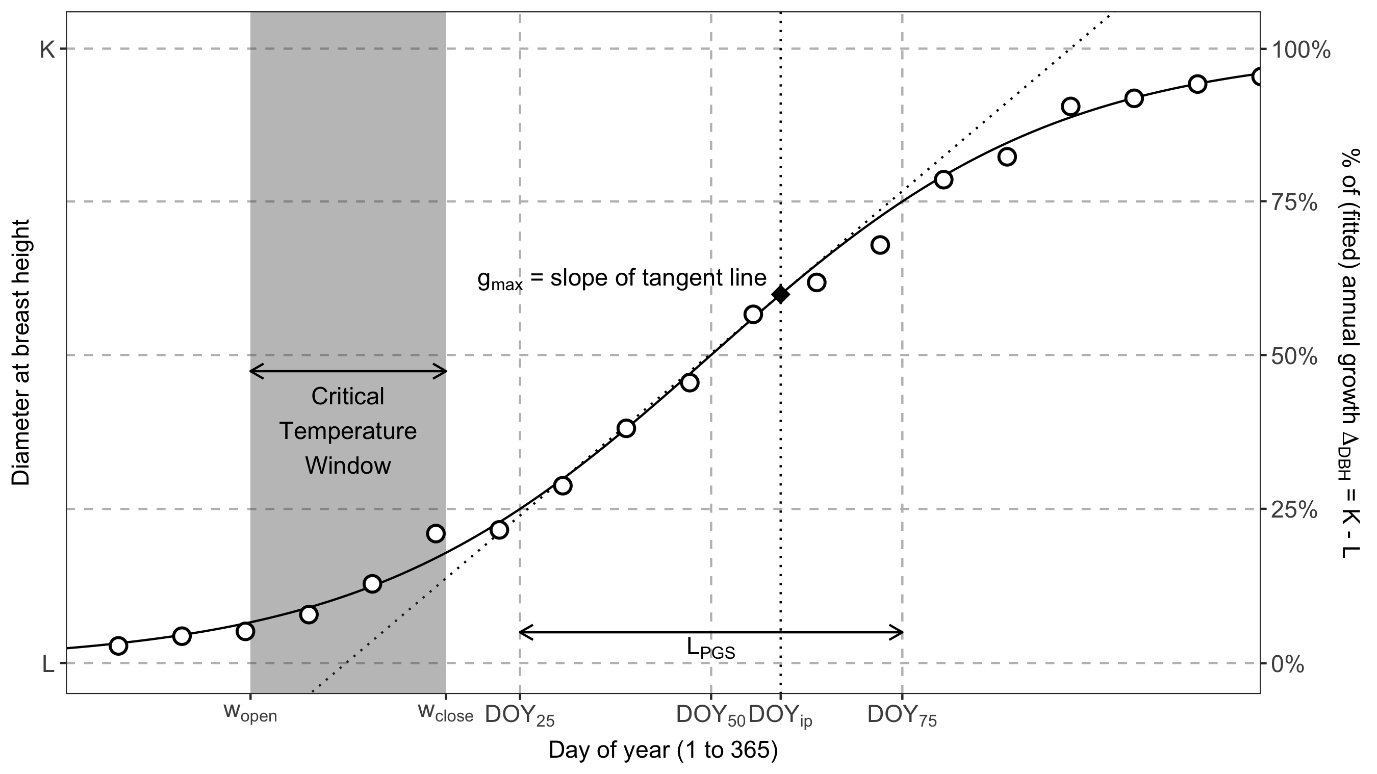

Figure 1. Schematic illustrating the parameters considered here. Shown are measurements for an example tree (## cm SPECIES), fit with the model of McMahon & Parker (2015), from which phenology and growth rate parameters are obtained.

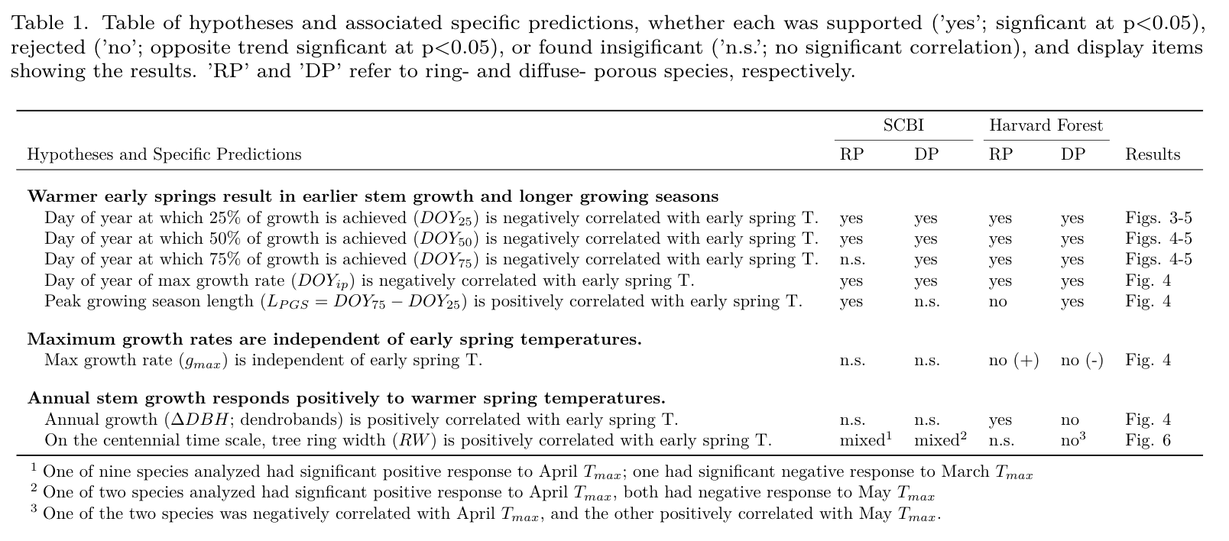

# Materials and Methods

## Study sites

Study sites included two temperate forests in the eastern United States, both part of the Forest Global Earth Observatory [ForestGEO; Anderson-Teixeira et al. 2015].

Our first study site was the forest dynamics plot located at the Smithsonian Conservation Biology Institute 5 km South of Front Royal, Virginia within the Blue Ridge Mountains (38.8935° N, 78.1454° W; elevation 273–338 m.a.s.l.). The forest here was established in the mid-19th century after conversion from agricultural fields. Dominate canopy species within the 25.6 ha forest plot include tulip poplar (*Liriodendron tulipifera*), oaks (*Quercus spp.*), hickories (*Carya spp.*). The climate is humid temperate, with a mean annual precipitation of 998 mm, January temperatures averaging 1 degrees C and July temperatures averaging 24 degrees C (Helcoski et al, 2019).

The second study site was Harvard Forest (42.5388° N, 72.1755° W, 340-368 m.a.s.l.), located near the central Massachusetts town of Petersham. *Harvard Forest was established in 1907 as a study site for university students and researchers. (Previous use?)* Dominate species within the approximately 13 HA plot are hemlock (*Tsuga spp.*), oak (*Quercus spp.*) and maple (*Acer spp.*). The climate is temperate continental with a mean annual precipitation of 1120 mm, January temperatures averaging -12 degrees C and July temperatures averaging 19 degrees C (D’Orangeville et al, ).

## Data preparation

### Dendrometer bands

Metal dendrometer bands installed on a total of 463 trees within the SCBI and Harvard Forest ForestGEO plots (Table 2). Bands were placed on dominant species, including two diffuse- and two ring-porous species at SCBI and eight diffuse- and three ring-porous species at Harvard Forest. Bands were measured with a digital caliper approximately every 1-2 weeks within the growing season from 2011-2020 at SCBI and 1998-2003 at Harvard Forest, respectively. The number of bands measured at each site fluctuated somewhat as trees were added or dropped (e.g., because of tree mortality) from the census (Table S1) *(tags_per_year_preclean in data folder)*. Across years, the number of bands sampled averaged *~135* (range: 99-145) at SCBI and *~717* (range: *700-755*) at Harvard Forest. In total, our analysis included 2459 tree-years (Table 2).

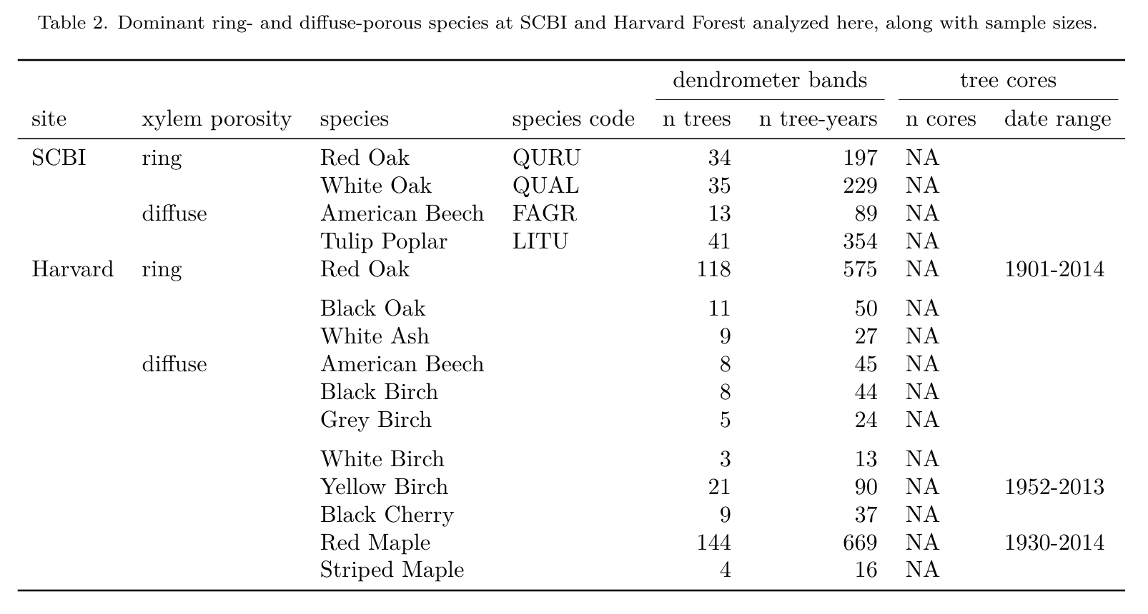

Measurements were timed to begin before the beginning of spring growth and to continue through the cessation of growth in the fall. At SCBI, the median start date was 4/14, which was adjusted when early leaf-out of understory shrubs and herbs was observed, with the earliest start date being March 30, 2020. Measurements were continued through to fall leaf senescence, with the median end date being 10/17 and the latest end date was November 26, 2012. Timing of measurements at Harvard Forest was similar, with the median start date of 4/23 and median end date of 10/30. 1998 was an anomalous year where initial measurements were taken on 1/5, but not taken again until 4/15. The latest end date was November 11, 2002.

The dendrometer band data were manually cleaned by visual inspection before analysis. We screened for three classes of mistakes. First, when a weekly measurement was drastically different from previous week and following weeks, this was assumed to be a measurement error and the record was removed. Second, when measurements remained essentially unchanged for several readings, followed by a sudden jump followed by normal growth pattern, this was assumed to be a case where the band was stuck and then released. In these cases, the full annual record for the tree was removed. Third, there were cases where data were clearly wrong but with unknown causes. In cases where several measurements were an issue, they were simply removed. If there were no clear solutions to ‘fix’ the data, the entire year was removed from the analysis.

We fit the model of McMahon & Parker (2015) to define *phenological dates and growth rates* (Fig. 1). This 5 parameter logistic model was fitted to each tag year’s dendrometer band measurements in R:

$$DBH=L+\frac{K−L}{1+1/θ⋅exp[−r(DOY−DOY_{ip})/θ)]^{θ}}$$

**(Cameron, please check equation following formatting. )** Here, $L$ and $K$ are lower and upper asymptotes of the model, corresponding to $DBH$ at the beginning and end of the year, respectively. $θ$ is a tuning parameter controlling the slope of the curve toward the upper asymptote, $r$ is the slope of the curve at the inflection point, $doy_{ip}$ is the day of year where the inflection point occurs, and $doy$ are the modeled days of year, in this case, 1-365. *We note that the maximum growth rate does not always occur on the doy_ip, and is controlled magically by theta somehow.* Using the optimized parameters for each tree year, we could then determine the $DBH$ on every day within that year, giving us the ability to extract the intra-annual growth variables we were interested in.

After model fitting, we used a script to remove poorly fit models. Models were judged to be poorly fit if certain modeled growth characteristics fell outside of the acceptable range we determined. Modeled tag years were removed under five conditions:  
(1) single day growth rates were higher than 2 standard deviations away from the mean for each wood-type (SCBI = 2, HF = 34); (2) DOY where peak growth rate occurred was 2 standard deviations away, calculated for each wood-type in each year (aimed to remove models which predicted growth to peak during the winter; SCBI = 62, HF = 106); (3) tree-years with small or negligible total growth ( $ΔDBH$ < 0.02 mm; SCBI = 0, HF = 66); (4) model fit predicted total yearly growth to take longer than 365 days (SCBI = 181, HF = 199); and (5) models with unexplained sharp spikes in growth rate (SCBI = 0, HF = 3). At Harvard Forest the tag years removed through this method was proportional to the original sample size, indicating that no species or size class was disproportionately removed compared to others *(SI figure? data_cleaning_figure_hf in manuscript folder)*. At SCBI a higher proportion of oak trees were removed *(data_cleaning_figure_scbi)*. The majority (White oak = 91, Red oak = 79) were removed in step 5 above, indicating that the LG5 model struggled to accurately model these these species.

### Tree-rings

Dominant tree species were cored at both sites following sampling designs that covered a broad range of $DBH$. We analyzed records for the dominant ring- and diffuse- porous species at each site (Table 2), excluding species with other xylem architectures (*Juglans nigra* L. at SCBI, *Tsuga Canadensis* (L.) Carrière at Harvard Forest) At SCBI, cores were collected as described in (**???**). Briefly, cores were taken from living or recently dead trees $≥$ 10 cm $DBH$, including a randomly sampled subset of all dominant species within the ForestGEO plot (live trees in 2010-2011; **???**) and trees found newly dead in annual tree mortality in 2016 and 2017 (**???**). At Harvard Forest, …(*Neil can write this easily, or KAT probably has the info*) In total, we analyzed 0 cores from eleven species at SCBI and three species at Harvard Forest (Table 2).

All cores were mounted, sanded, cross-dated, and measured using standard methodology. (*describe chronology building– as in (****???****)– Neil can do this quickly*) Start year was defined at SSS=0.8.

### Climate

For the dendrometer band analysis, we used climate data from local weather stations. Daily maximum and minimum temperatures ( $T_{max}$ and $T_{min}$, respectively) for SCBI were obtained from a meteorological tower adjacent to the SCBI ForestGEO plot, via the ForestGEO Climate Data Portal v1.0 (<https://forestgeo.github.io/Climate/>; **???**). Daily temperature records for Harvard Forest were obtained from the Harvard Forest weather station (Boose & Gould, 2004; Boose, 2018). The R package climpact () was used to plot temperatures for visual inspection. Climpact also identifies readings that were greater than 3 standard deviations away from yearly means. These points were labeled as outliers and removed from the dataset. Gaps in the SCBI meteorological tower data were subsequently filled using temperature readings obtained from a National Center for Environmental Information (NCEI) weather station located in Front Royal, Virginia (<https://www.ncdc.noaa.gov/cdo-web/datasets/GHCND/stations/GHCND:USC00443229/detail>). (*how were gaps filled for Harvard? Or was the record good?*)

For the tree-ring analysis, we obtained monthly $T_{max}$ and $T_{min}$ data for 1901-2019 from CRU v.4.04 (**???**), again via the ForestGEO Climate Data Portal v1.0 (**???**).

## (Climwin)

The period where the phenology milestone(s) were most affected by changes in early spring temperature was determined using the R package Climwin. This package tests the correlation between climate variables ($T_{MAX}$) and biological variables (DOY, max rate DOY, total growth) within a specified time-frame, reporting correlation and delta AIC’s of each ‘window’. as the best-model. We instructed Climwin to search for the best window beginning at February 1st and ending at the mean DOY for each phenology variable (chart in SI?). This was done to find corresponding (median of 95% CI window open and close) start and end dates for the analysis of ring-porous and diffuse-porous trees, as well as all trees pooled together.

## Hypothesis testing

Correlation between these variables and spring temperatures over the 15 year study period (1998-2003; 2011-2019) were assessed using a linear mixed model in a heriarchal bayesian framework.

Notes for now:

1. The multivariate model for $(DOY_{25},DOY_{50},DOY_{75})$ has:
   1. Fixed effects: The interaction between wood type (diffuse vs ring porous) and climwin mean
   2. Random effects: tag number (no species just yet)

-Mixed effect model

A mixed effect model was used to test the response of wood phenology variables (25% DOY, 50% DOY, 75% DOY, max-rate, max-rate DOY, total growth) to fixed effects of wood-type and spring temperature, along with random effects of species and tag. We ran two separate models of each wood phenology variable for each of our major wood-types, and one combined model to use for comparison. Models were run using the LME4 package in R (Bates, D., Mächler, M., Bolker, B. & Walker, S. (2015). Fitting linear mixed‐effects models using lme4. J. Stat. Softw., 67, 1–48.)

• Bayesian heirarchical model This mixed-effect model was run within a hierarchical Bayesian framework and fit using the rstanarm R interface to the Stan programming language (**???**). In all cases unless otherwise specified, all prior distributions are set to be the weakly informative defaults.

# Results

## Phenological patterns

Across all trees and years at SCBI, 25% of annual growth was achieved on May 20 ($DOY_{25}$ =139), 50% on June 12 ($DOY_{50}$ =162), and 75% on July 5 ($DOY_{75}$ =185), for an average peak growing season length of 45 days. Maximum growth rate occurred just one day after $DOY_{50}$ on June 13 ($DOY_{max}$ =163). At Harvard Forest, 25% of annual growth was achieved on June 1 ($DOY_{25}$ =151), 50% on June 23 ($DOY_{50}$ =173), and 75% on July 14 ($DOY_{75}$ =194), for an average peak growing season length of 43 days. Maximum growth rate occurred on June 24 ($DOY_{max}$ =174).

At both sites, growth phenology differed between ring- and diffuse- porous species (Fig. 2, Table 3). Specifically, ring-porous species began growing earlier, reaching the $DOY_{25}$ benchmark 31 days earlier at SCBI and 32 days earlier at Harvard Forest. Growth of ring-porous species was spread out over a longer growing season, with average $L_{PGS}$ of ring-porous species being **21** days longer at SCBI and **19** days longer at Harvard Forest. *(These numbers are calculated as based on mean DOY75- mean DOY25, whereas we want mean [DOY75- DOY25]. Need to fix this, but I filled in approximate numbers for now.)*

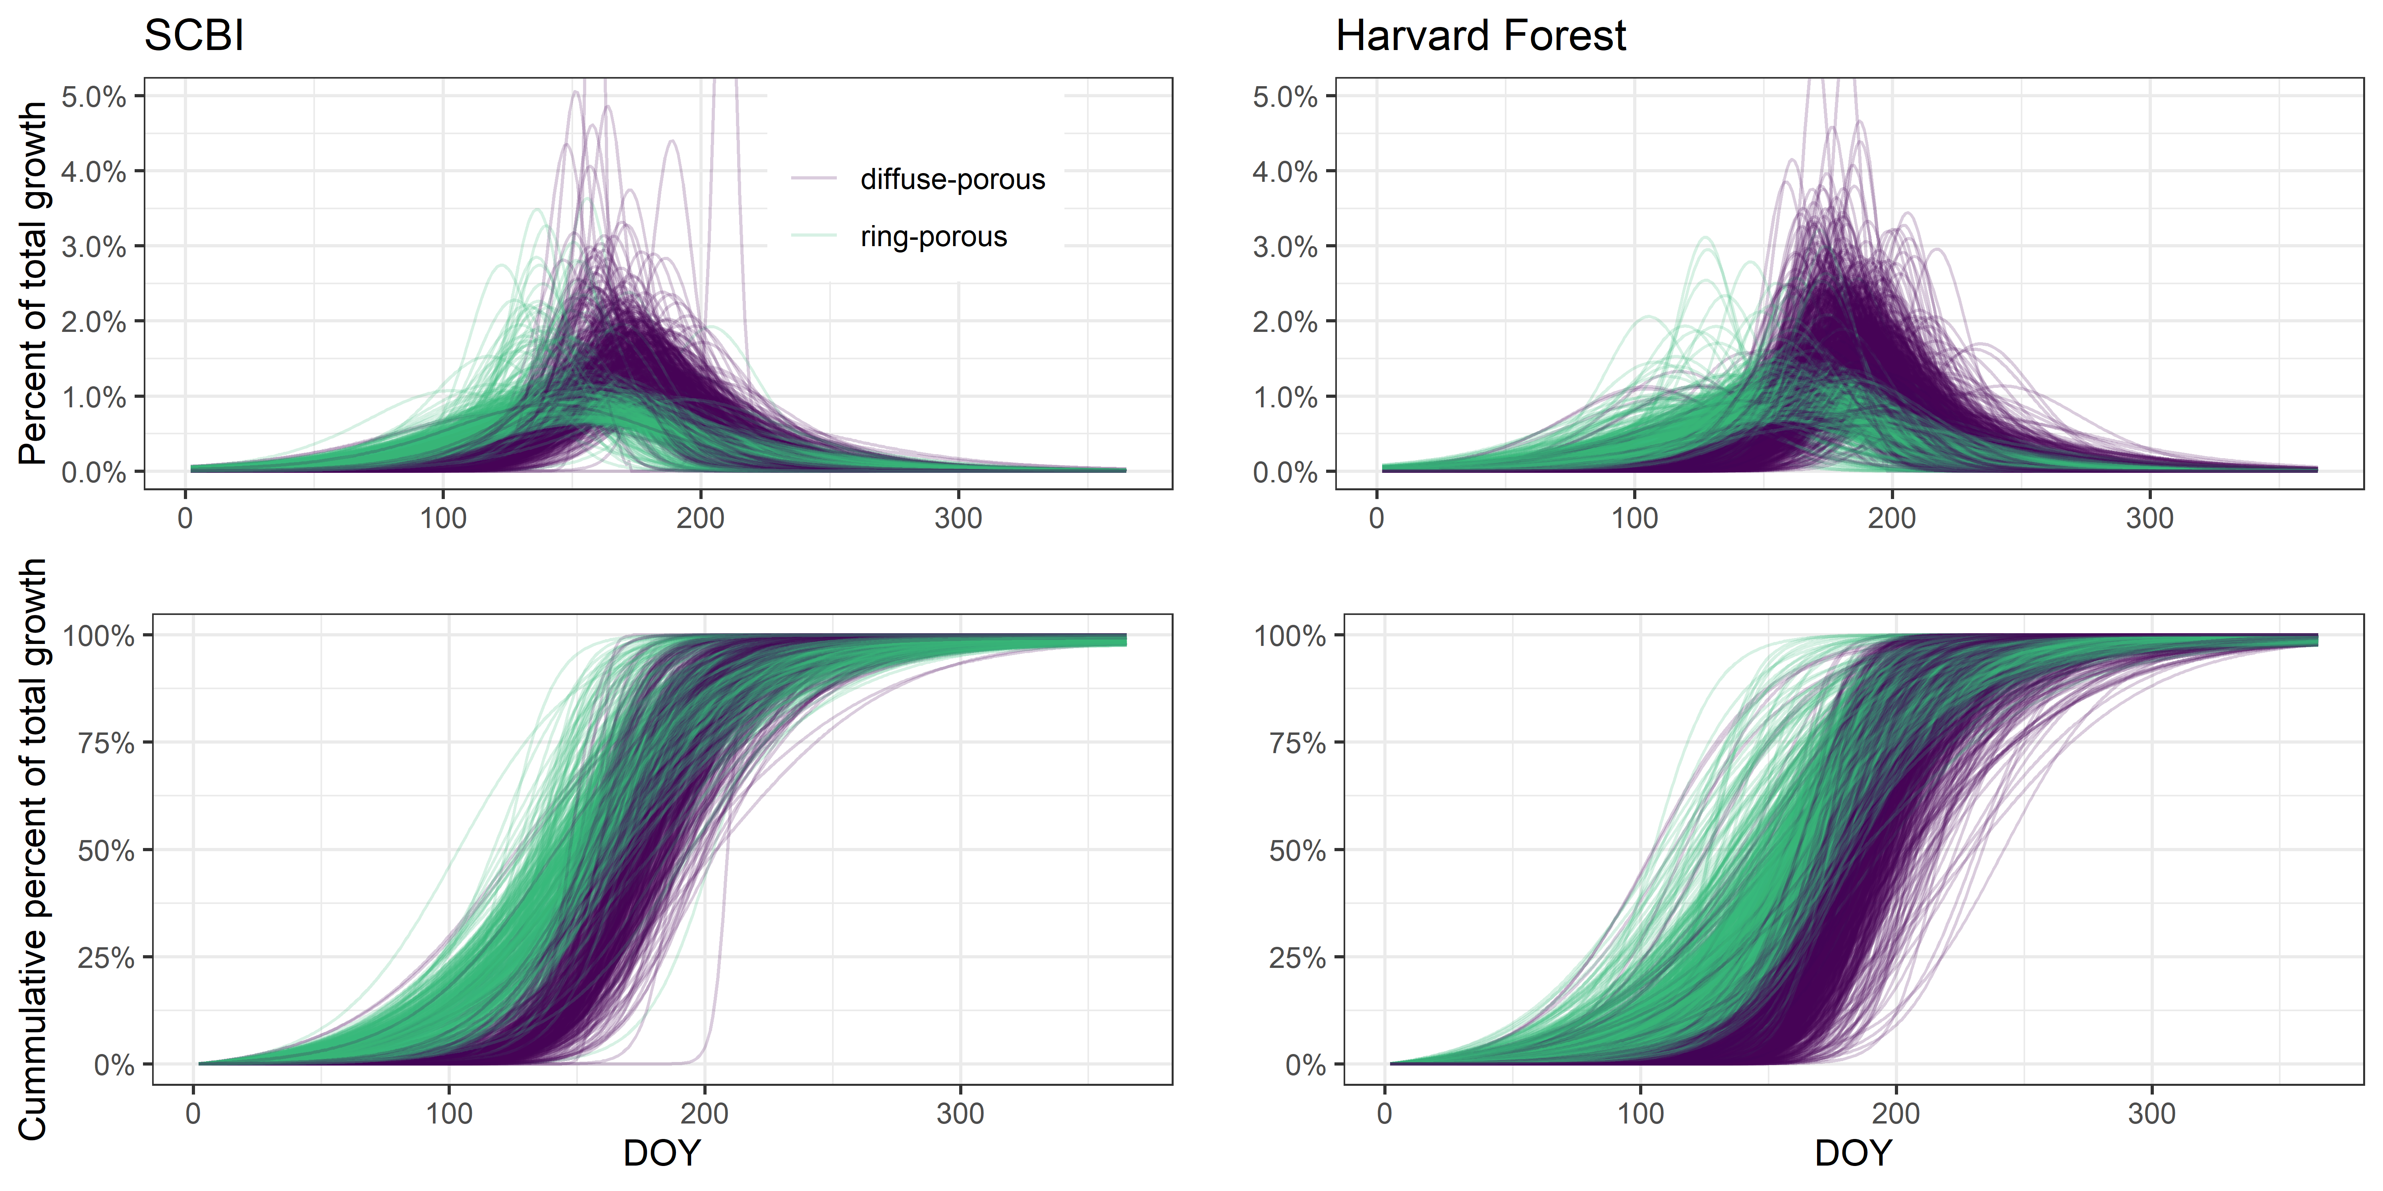

Figure 2. Growth trajectories for ring- and diffuse-porous trees, as both relative and cumulative fractions of total annual growth. Each line represents one year’s growth for a given tree, fit with McMahon model.

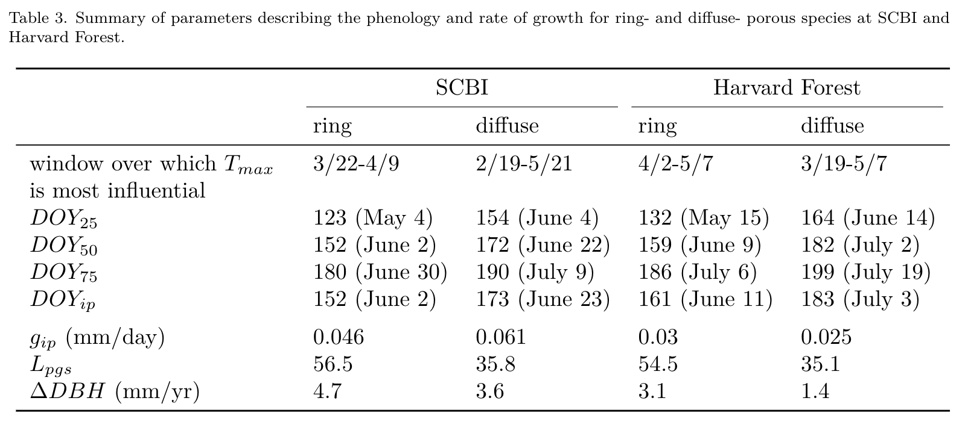

## Optimal climate windows

For the majority of weekly time windows from Jan. 1 to $DOY_{25}$, there was neutral negative relationship between temperature and $DOY_{25}$, meaning that warmer temperatures shifted growth earlier in the season (Figs. 3, S1-S4). This held true for both ring- and diffuse-porous trees at both sites. The strongest relationships, including but not limited to the optimal time windows (Table 3), occurred for time windows closing $≤$ 5 weeks prior to $DOY_{25}$. (In general, there were significant negative relationships between temperature and $DOY_{25}$ for any time period beginning $≥$**5** weeks prior to $DOY_{25}$, ending $≤$**8-20** weeks prior depending on wood-type and site, and covering at least a **3**-week period ( S1-S4). Relationships tended to be weaker and more stochastic in sign for short time periods, particularly those just prior to $DOY_{25}$.) (**Cameron, I’m not sure if the above text is up-to-date… Also, see** [**issue 34**](https://github.com/EcoClimLab/growth_phenology/issues/34) )



Figure 3. Landscapes of relationships between the day of year on which 25% of annual growth is achieved (DOY_25) and temperature in prior weeks for ring- and diffuse-porous trees at SCBI and Harvard Forest. Shown are matrices of linear coefficients of first-order linear regressions between temperature and DOY_25, where Window Open and Window Close indicate number of weeks prior to DOY_25 (ring-porous: May 4 at SCBI, May 15 at HF; diffuse-porous: June 4 at SCBI, June 14 at HF). Black boxes indicate the optimal window (ring-porous: March 22- April 9 at SCBI, April 2 - May 07 at HF; diffuse-porous: Feb. 19- May 21 at SCBI, March 19 - May 07 at HF).

## Climate sensitivity of phenology

For both ring- and diffuse- porous species at both sites, warmer spring temperatures resulted in earlier achievement of growth milestones (Tables 1, Figs. 4, 5). Specifically, $DOY_{25}$, $DOY_{50}$, and $DOY_{g.max}$ at SCBI and $DOY_{25}$, $DOY_{50}$, $DOY_{75}$, and $DOY_{g.max}$ at Harvard Forest all decreased significantly with increasing $T_{max}$ during the critical period (Table 3).



Figure 4. Relationship between growth parameters and climwin mean temperatures. For each observed climwin mean temperature value, the posterior mean of the fitted day of year is represented by the solid blue line and credible intervals are represented by bands.

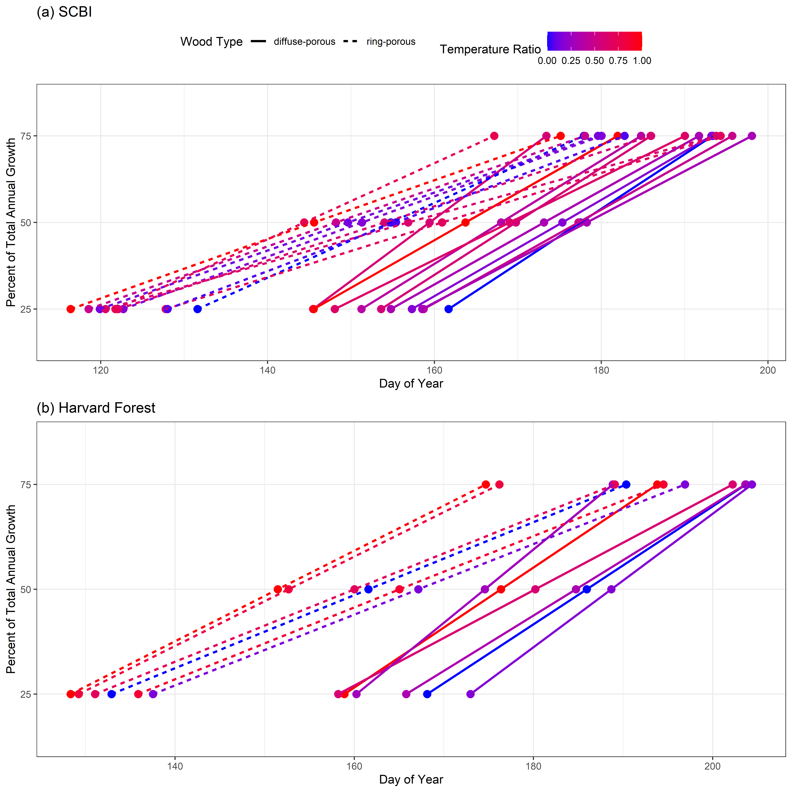

Figure 5. Day of year where growth milestones were achied at (a) the Smithonian Conservation Biology Institute and (b) Harvard Forest.

At SCBI, ring-porous $DOY_{25}$ and $DOY_{50}$ shifted earlier while $DOY_{75}$ did not shift, resulting in longer peak growing season length when critical window temperatures were warmer (Tables 1, Figs. 4, 5). Diffuse-porous $DOY_{25}$, $DOY_{50}$, and $DOY_{75}$ shifted earlier uniformly resulting in no significant change in peak growing season length. At Harvard Forest, ring-porous $DOY_{75}$ shifted more than $DOY_{25}$, resulting in shorter peak growing season length, while diffuse-porous $DOY_{25}$ shifted more than $DOY_{75}$, resulting in an extended peak growing season length in response to warmer critical window temperatures.

## Climate sensitivity of growth

Maximum growth rate, $g_{max}$, was not consistently linked to early spring temperatures (Tables 1, Fig. 4). Ring-porous species exhibited no change (SCBI) or a slight increase (Harvard Forest) with warmer early spring temperatures. In contrast, diffuse-porous species exhibited no change (SCBI) or lower $g_{max}$ in years with higher early spring $T_{max}$.

Total annual growth measured with dendrometer bands, $ΔDBH$, also was not consistently linked to early spring temperatures, displaying either no relationship (SCBI) or extremely small changes (Harvard Forest) (Tables 1, Fig. 4).

Annual growth recorded in tree-ring records, $RW$, …

Figure 6. Climate sensitiivity of annual growth, as derived from tree-rings, for dominant ring- and diffuse- porous species at the Smithonian Conservation Biology Institute and Harvard Forest. Shown are Pearson correlations between ring-width index and and monthly Tmax. Species codes are as given in Table 2.

Figure 6. Climate sensitiivity of annual growth, as derived from tree-rings, for dominant ring- and diffuse- porous species at the Smithonian Conservation Biology Institute and Harvard Forest. Shown are Pearson correlations between ring-width index and and monthly Tmax. Species codes are as given in Table 2.

# Discussion

We found that warmer spring temperatures in temperate deciduous forests cause earlier tree growth but have little effect on annual woody productivity…

Although the number of years analyzed here is limited (# years at SCBI, # years at HF), the signal is clear and consistent: for both species groups at both sites, warmer temperatures during virtually any part of the spring led to significantly earlier achievement of growth milestones (*CITE RELEVANT FIGS & TABLES* ). This indicates that this is not a subtle effect. However, the effect on L_PGS, r_max, and $ΔDBH$, if any, is subtle, and a much longer record would be needed to detect such effects. Fortunately, we were able to get at annual growth using tree-ring data (Fig. 6). These confirm that the effect of spring temperatures on annual growth is modest and generally not significant, while revealing a slightly more complex picture. Although spring temperatures prior to May rarely had a significant influence on …

THe tree-rings also reveal that the strongest temperature sensitivity aligned with peak growing season. This pattern is common across tree-ring studies in temperate deciduous forests. (*1-2 sentences generalizing about climate sensitivity of temperate deciduous forest growth–Neil can do this most easily.*) Thus, while our analysis is limited to two sites, we expect that the finding that spring temperatures have limited effect on annual tree growth will hold generally.

Our findings contribute to a broader picture of the influence of spring temperatures on forest ecosystem function. Warm spring temperatures result in earlier leaf-out (REFS), an earlier start to net C sequestration (REFS), and–as shown here–earlier initiation of stem growth (*CITE RELEVANT FIGS & TABLES* ). Yet, an earlier start to the growing season does not imply a longer growing season (Table 1, Figs 4, 5; **???**). Rather, growth finishes sooner– presumably because of *C sink limitation* (**???**). As sink limitation controls the end of woody growing season (**???**), we might expect that an earlier start to growth buffers against unfavorable growth conditions during the peak growing season (e.g., drought). *Do we see any evidence of this???*

As climate change accelerates and spring temperatures become increasingly warmer, growing seasons will start earlier, but this is unlikely to provide the increased carbon sequestration that is anticipated in most models (Table 1; Figs. 4, 6; **???**). The implication is that temperate deciduous forests are likely to sequester less CO2 than most models suggest, implying that models are underestimating future atmospheric CO2 overall.

~~~~ ## Cam’s previous content

We have shown that intraannual growth patterns in North American temperate trees change in response to increasing spring temperatures. The magnitude of these changes depends largely on the evolutionary differences inherent in the two wood types analyzed here. Ring-porous trees must repair winter embolism of their large xylem vessels before leaf expansion, achieving roughly 25% total yearly growth simultaneously with bud burst, and 50% yearly growth around the time of 75% leaf emergence (D’Orangeville et al,). On the other hand, diffuse-porous trees are less prone to cavitation and so do not need to repair winter embolism before bud burst, allowing up to 75% leaf out before reaching their 25% yearly growth totals (D’Orangeville et al). These differences are likely evolutionary hydraulic adaptations to climate (Baas & Wheeler, 2011). The presence of wide-xylem cells in ring-porous trees allows for greater water conductivity in the spring at the cost of increased cavitation risk during spring drought, and high likelihood of damage during frost events (Cochard & Tyree, 1990; Sperry et al, 1994). The pre-leaf stem growth occurring in these species is fueled by non-structural carbon stores, often used for other cell maintenance activities within the plant (Sperry et al, 1994; Palacio et al, 2014; Sevanto et al, 2014). The dependence on these carbon stores for cambial activation could prove to be detrimental to long-term health of the tree, as exhaustion of reserves leads to carbon starvation (Sevanto et al, 2014). Diffuse-porous trees have narrower xylem cells lowering the risk of cavitation, but leading to a decreased water conductivity in the spring, revealing a growth strategy more focused on a relatively faster, shorter growing season in the Summer (Sperry et al, 1994). This allows the diffuse-porous trees to conserve their carbon stores, making them potentially more resistant to pest/pathogen invasions?, but exposing them to higher temperatures and drought risk during their Summer-centered growth period.

The mechanisms controlling activation of cambium reactivation is still debated, as some speculate Auxin, the chemical believed to kick-start the reactivation process, originates in the leaves (Frankenstein et al, 2005). However, the fact that ring-porous species complete 25% growth before the presence of leaf buds indicates there may be another source of Auxin production. *READ MORE ABOUT THIS!* The relationship between earlier cambial reactivation and early spring temperature signals that the mechanism is influenced by temperature?

Under the warming regime analyzed here, ring-porous trees reach 25% and 50% growth milestones earlier (insert actual # days?) in the year, while timing of 75% growth !!! Changed by constant amount !!! . This implies that the growing season of ring-porous trees expanded due to spring temperatures, which are projected to continue to increase as anthropogenic global warming intensifies. In fact, we found a positive correlation between ring-porous growing season length and spring temperature, while no such relationship was observed in diffuse-porous trees. The earlier reactivation of cambial cells is potentially exposing these trees to higher risk of cavitation or damage during frost events (Cochard & Tyree, 1990). Damage of this nature would then need to be repaired using carbon reserves, which may be in short demand as they are already being used for initial growth.This would negatively impact the plant’s ability to maintain cell health, or reduce the ability to respond to invasion of pests or pathogens. Alternatively, the extension of growth season and higher yearly growth totals like we see here, could give ring-porous trees a competitive advantage over their non-responsive diffuse-porous counterparts.

Diffuse-porous growth timing seems relatively unaffected by early spring temperatures, instead showing a higher correlation with late spring or Summer temps. This disconnect means that diffuse-porous trees will continue to focus their growing season in the Summer, which is projected to become less conducive to tree growth as temperatures and drought intensity increase in some areas. —- Studies have found that diffuse-porous trees in the Eastern USA show a larger reduction in ring-width increment during, and following Summer droughts when compared to species of other wood types (Orwig & Abrams, 1997; Kannenberg et al, 2018) as well as greater sensitivity to Summer precipitation patterns (Elliot et al, 2015). The potential for more frequent reduction in growth coupled with the increased growing season length of ring-porous species may lead to an alteration in forest species composition as diffuse-porous species are outcompeted.

–the range of some of these species may migrate North to cooler summer conditions becoming potentially extant in the Southern / mid Atlantic of the USA.– (Is mortality of ring-porous species higher in recent decades? Hard to pinpoint, but would likely be caused by warmer early-spring followed by late frost events exhausting NSC reserves?)

This analysis is one of a first generation of intraannual dendroband tree growth studies, and as such, is only the tip of the ice berg. Here, we focused our analysis purely on early spring warming. This falls short of the reality of our changing climate, where each season is being affected in some way, leading to a combination of stressors on plant growth. For example, diffuse porous trees seemed to show little, if any, relationship with the climate window defined here, but if we shift that window forward 20 days, the effect increases dramatically, signalling a greater importance of May/June $T_{MAX}$ on trees of that wood type (figure or table?). This revelation agrees with the results from other climate sensitivity studies like Helcoski et al (2019), which found differences in interspecific growth responses to several climate variables throughout the year. Additionally, Other studies have found that Autumn leaf senescence is being delayed in response to warmer temperatures in the previous year’s Winter or Autumn (), positive correlation between growth and higher winter temperatures (Heide, 1993; Delpierre et al, 2009), stunted total productivity induced by drought and high $T_{MAX}$ in the current year’s Summer (), and an increase in diffuse-porous tree growth during the growing season following an abnormally cold winter (Benito & Pederson, 2015; Elliot et al, 2015). How these relationships may impact intraannual growth patterns is uncertain, but identifying such relationships will help us further understand how climate change is impacting forests.

We present a stepping stone for future studies to build upon.

# (Content to incorporate)

new Science paper: (**???**)

(**???**)

From Neil: Zhang et al. (2021), Zhang et al. (2020)

effect of spring temperature on annual growth in New England: (**???**)

results align with Fu et al. (2019), which shows that interannual variation in NEE is more strongly linked to peak C uptake rates than to growing season length. Our study demonstrates that this holds true for $ANPP_{woody}$ as well as NEE.

Geng et al. 2020 GCB- Climate warming increases spring phenological differences among temperate trees.

N. American strategies have conservative strategies when it comes to phenology, as historically they’ve been subject to more spring frosts. Thus, climate change is having less impact (Zohner et al., 2020); Leaf velocity discussion? - - RP trees BB = 25% and 75% leaf development = 50% growth (D’Orangeville). Are DP trees leafing up earlier? If yes, how much earlier? Similar to 25,50,75% DOY retreat?

Another study found that the velocity of leaf development is correlated to bud burst timing, such that the later in the spring bud burst occurred, the faster leaves developed and vice versa (Klosterman & Hufkins & Richardson, 2018).

The timing of tree growth has profound impacts on ecosystem interactions, as well as dictates periods of highest drought sensitivity in temperate forests (Foster, 2014; D’Orangeville et al. in review). Species have co-evolved to utilize the phenological stages of trees at specific times in the year. If the timing of intraannual phenology traits were to shift, that could harm the species depending on the trees (). Additionally, if a drought were to occur when trees were at their peak growth rates, the resulting decrease in that year’s NPP would reduce the total amount of carbon sequestered, contributing to a climate feedback loop further exacerbating these potential shifts (source?).

# Acknowledgements

people: (everyone who helped collect data), Jess Shue (data) Funding: ForestGEO

# Author Contributions

# Supporting Information

Table S1. Sample size by year

Figure S1. Full climwin output for DOY 25 for ring porous species at SCBI.

Figure S2. Full climwin output for DOY 25 for diffuse porous species at SCBI.

Figure S3. Full climwin output for DOY 25 for ring porous species at Harvard Forest.

Figure S4. Full climwin output for DOY 25 for diffuse porous species at Harvard Forest.

# References

Bonan, G. B. (2008). Forests and Climate Change: Forcings, Feedbacks, and the Climate Benefits of Forests. *Science*, *320*(5882), 1444–1449.

Churkina, G., Schimel, D., Braswell, B. H., & Xiao, X. (2005). Spatial analysis of growing season length control over net ecosystem exchange. *Global Change Biology*, *11*(10), 1777–1787. <https://doi.org/10.1111/j.1365-2486.2005.001012.x>

Friedlingstein, P., Cox, P., Betts, R., Bopp, L., von Bloh, W., Brovkin, V., Cadule, P., Doney, S., Eby, M., Fung, I., Bala, G., John, J., Jones, C., Joos, F., Kato, T., Kawamiya, M., Knorr, W., Lindsay, K., Matthews, H. D., … Zeng, N. (2006). ClimateCarbon Cycle Feedback Analysis: Results from the C4MIP Model Intercomparison. *Journal of Climate*, *19*(14), 3337–3353. <https://doi.org/10.1175/JCLI3800.1>

Fu, Z., Stoy, P. C., Poulter, B., Gerken, T., Zhang, Z., Wakbulcho, G., & Niu, S. (2019). Maximum carbon uptake rate dominates the interannual variability of global net ecosystem exchange. *Global Change Biology*, *25*(10), 3381–3394. <https://doi.org/10.1111/gcb.14731>

Keenan, T. F., Gray, J., Friedl, M. A., Toomey, M., Bohrer, G., Hollinger, D. Y., Munger, J. W., O’Keefe, J., Schmid, H. P., Wing, I. S., Yang, B., & Richardson, A. D. (2014). Net carbon uptake has increased through warming-induced changes in temperate forest phenology. *Nature Climate Change*, *4*(7), 598–604. <https://doi.org/10.1038/nclimate2253>

McMahon, S. M., & Parker, G. G. (2015). A general model of intra-annual tree growth using dendrometer bands. *Ecology and Evolution*, *5*(2), 243–254. <https://doi.org/10.1002/ece3.1117>

Zhang, J., Alexander, M. R., Gou, X., Deslauriers, A., Fonti, P., Zhang, F., & Pederson, N. (2020). Extended xylogenesis and stem biomass production in Juniperus przewalskii Kom. During extreme late-season climatic events. *Annals of Forest Science*, *77*(4). <https://doi.org/10.1007/s13595-020-01008-1>

Zhang, J., Gou, X., Alexander, M. R., Xia, J., Wang, F., Zhang, F., Man, Z., & Pederson, N. (2021). Drought limits wood production of Juniperus przewalskii even as growing seasons lengthens in a cold and arid environment. *CATENA*, *196*, 104936. <https://doi.org/10.1016/j.catena.2020.104936>

Zhou, S., Zhang, Y., Caylor, K. K., Luo, Y., Xiao, X., Ciais, P., Huang, Y., & Wang, G. (2016). Explaining inter-annual variability of gross primary productivity from plant phenology and physiology. *Agricultural and Forest Meteorology*, *226-227*, 246–256. <https://doi.org/10.1016/j.agrformet.2016.06.010>